Test Case: tc002_SPX_Dev5_Crear_Requisicion_Spot_Con_FAD_Tipo_Cobro_CC
Step 1 - Enter username and password and click to button Enter : Credentials Entered
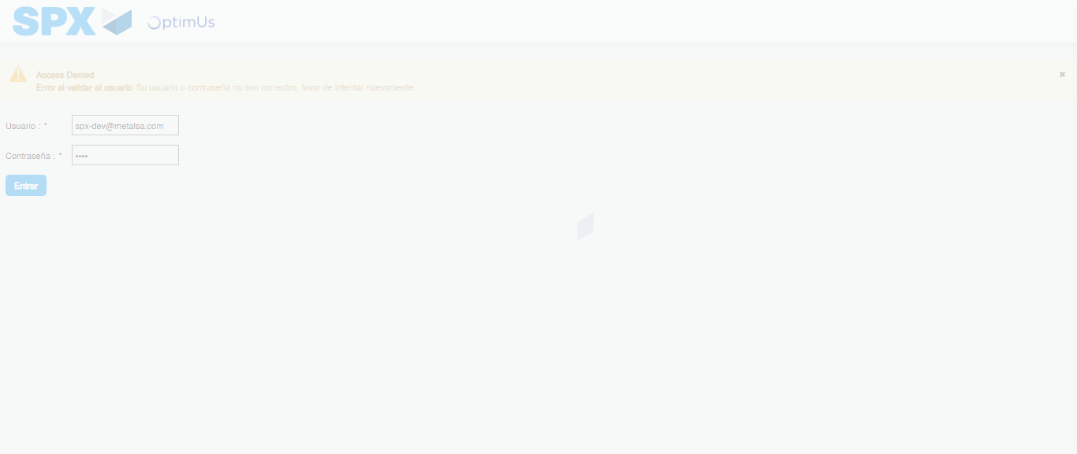Image file-name: QC_Testing-tc002_SPX_Dev5_Crear_Requisicion_Spot_Con_FAD_Tipo_Cobro_CC-1790178953776

Step 2 - Select to UEN and Access to Spot Buy Requisitions : UEN Correctly selected and Correct access
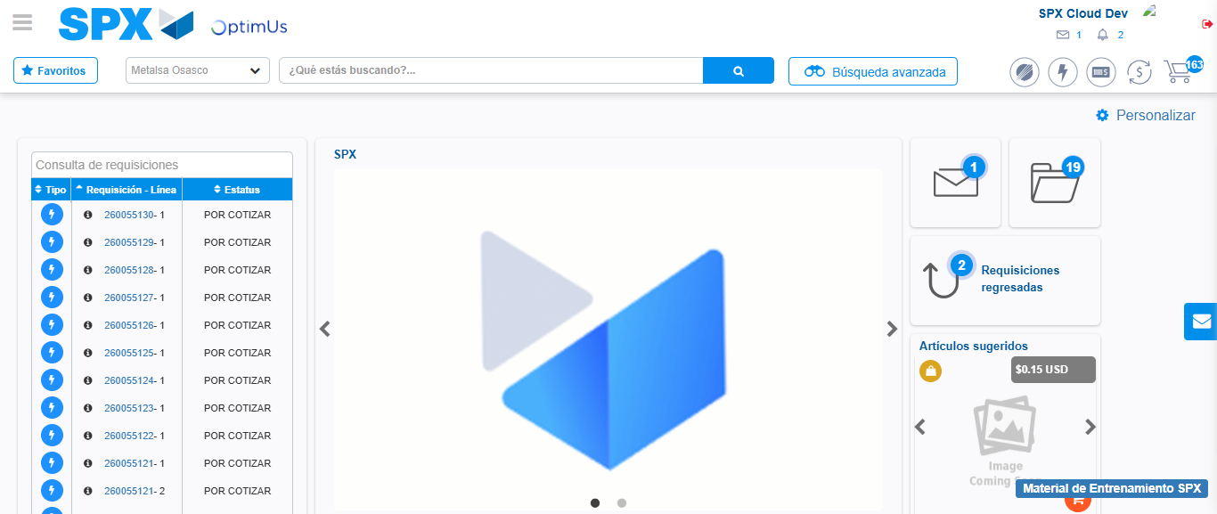Image file-name: QC_Testing-tc002_SPX_Dev5_Crear_Requisicion_Spot_Con_FAD_Tipo_Cobro_CC-1790178984890

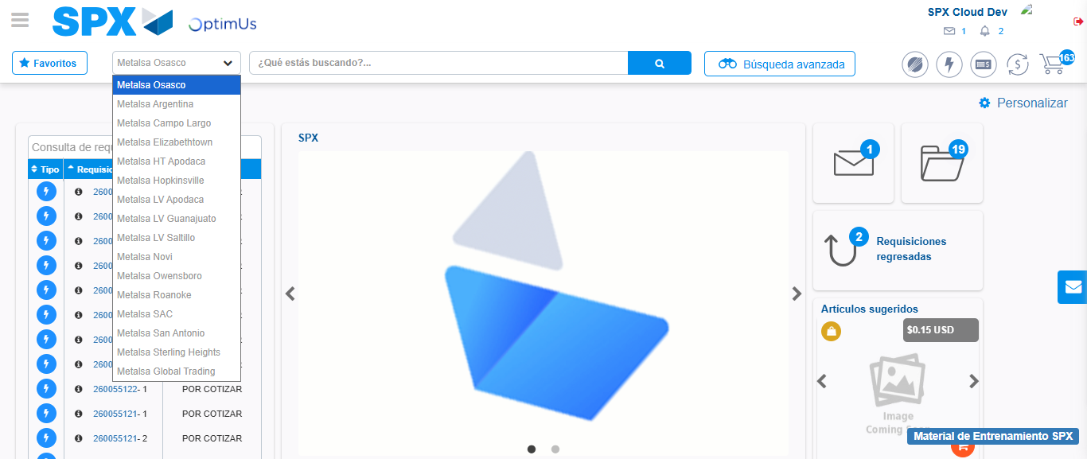Image file-name: QC_Testing-tc002_SPX_Dev5_Crear_Requisicion_Spot_Con_FAD_Tipo_Cobro_CC-1790178985375

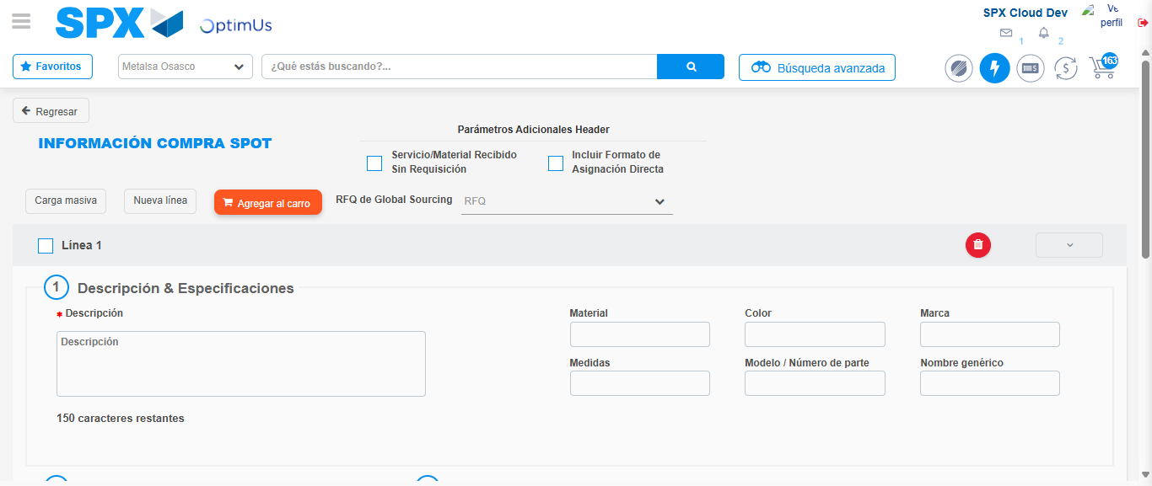Image file-name: QC_Testing-tc002_SPX_Dev5_Crear_Requisicion_Spot_Con_FAD_Tipo_Cobro_CC-1790178989461

Step 3 - Add FAD to Requisition: FAD Successfully Added
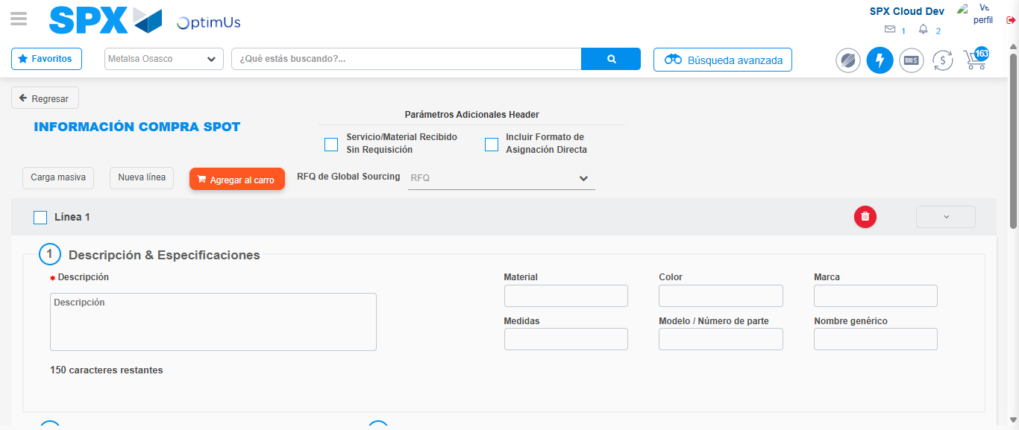Image file-name: QC_Testing-tc002_SPX_Dev5_Crear_Requisicion_Spot_Con_FAD_Tipo_Cobro_CC-1790178989720

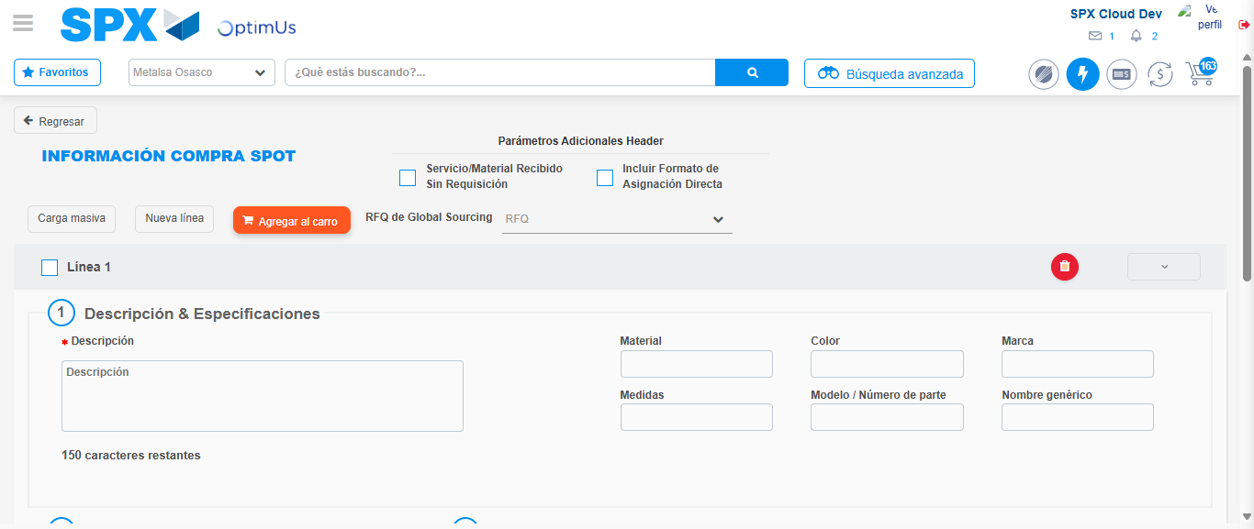Image file-name: QC_Testing-tc002_SPX_Dev5_Crear_Requisicion_Spot_Con_FAD_Tipo_Cobro_CC-1790178989957

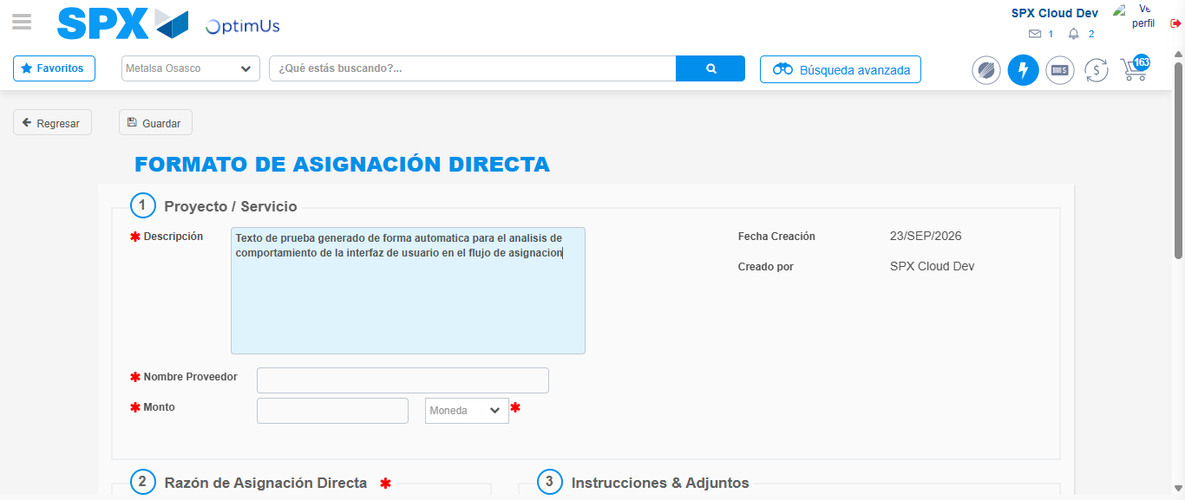Image file-name: QC_Testing-tc002_SPX_Dev5_Crear_Requisicion_Spot_Con_FAD_Tipo_Cobro_CC-1790178992589

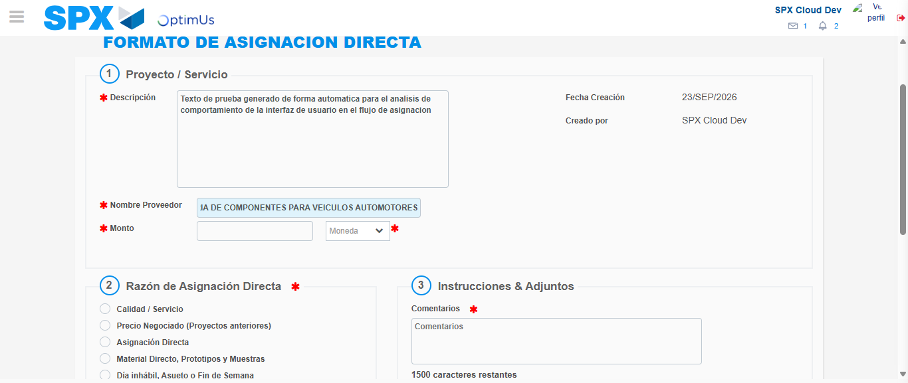Image file-name: QC_Testing-tc002_SPX_Dev5_Crear_Requisicion_Spot_Con_FAD_Tipo_Cobro_CC-1790179001000

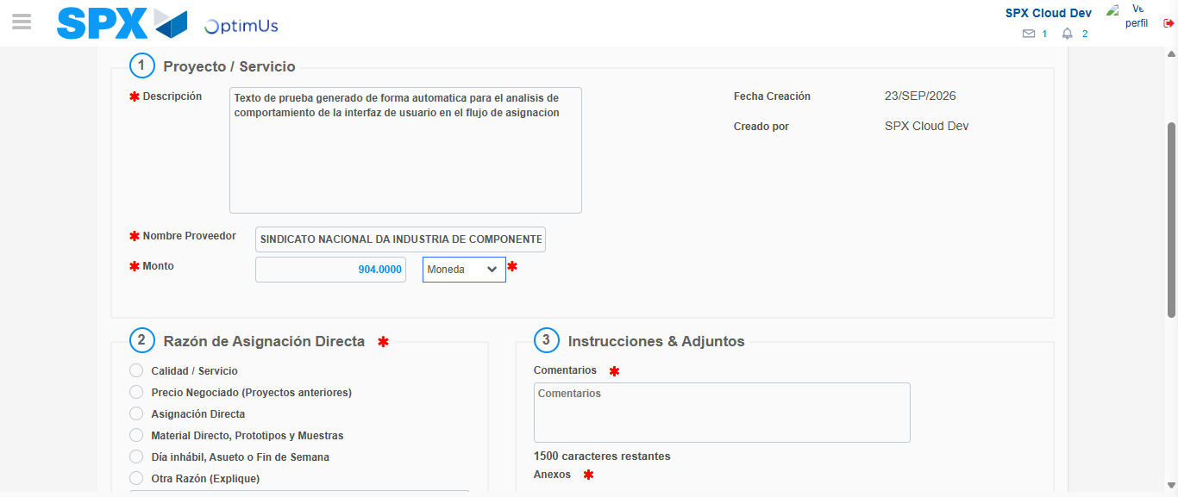Image file-name: QC_Testing-tc002_SPX_Dev5_Crear_Requisicion_Spot_Con_FAD_Tipo_Cobro_CC-1790179001312

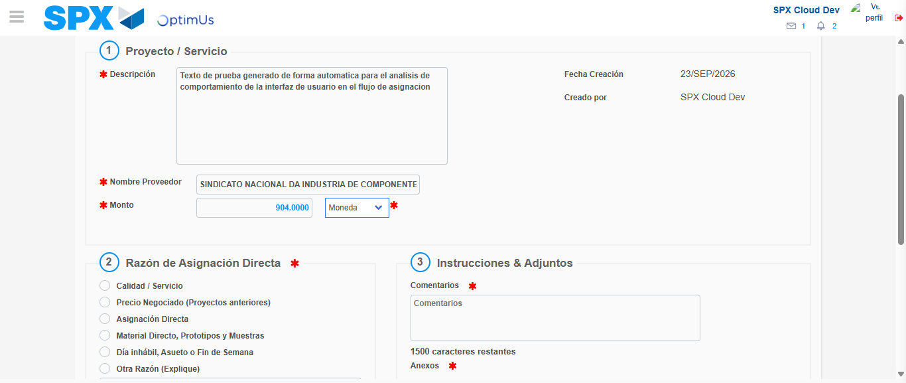Image file-name: QC_Testing-tc002_SPX_Dev5_Crear_Requisicion_Spot_Con_FAD_Tipo_Cobro_CC-1790179001512

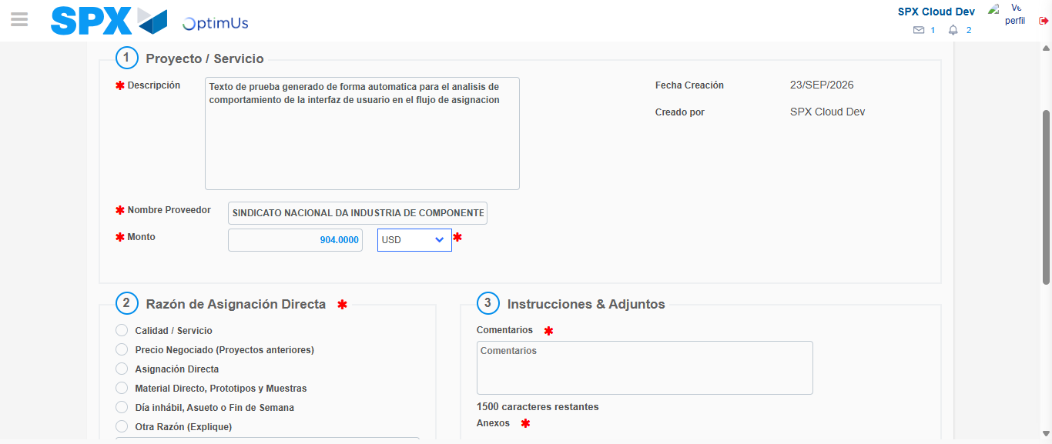Image file-name: QC_Testing-tc002_SPX_Dev5_Crear_Requisicion_Spot_Con_FAD_Tipo_Cobro_CC-1790179001813

Image file-name: QC_Testing-tc002_SPX_Dev5_Crear_Requisicion_Spot_Con_FAD_Tipo_Cobro_CC-1790179001994

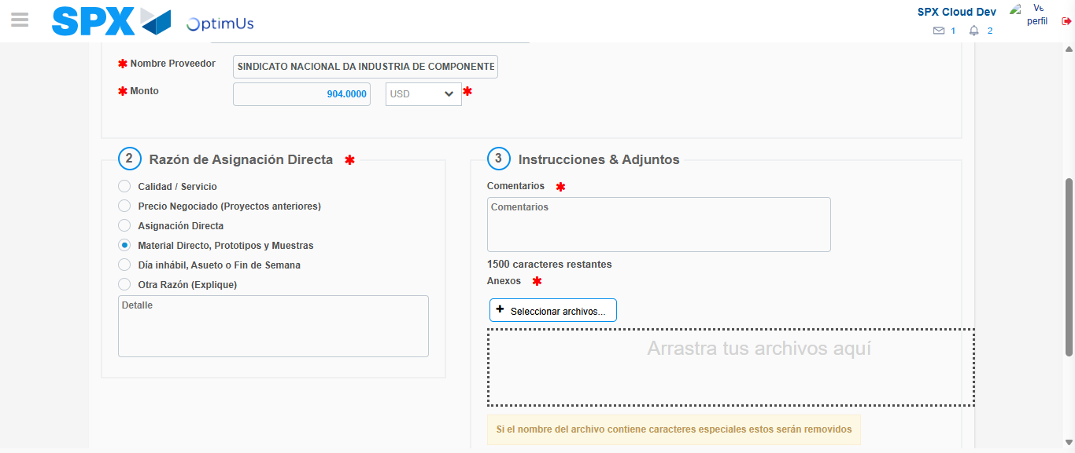Image file-name: QC_Testing-tc002_SPX_Dev5_Crear_Requisicion_Spot_Con_FAD_Tipo_Cobro_CC-1790179002757

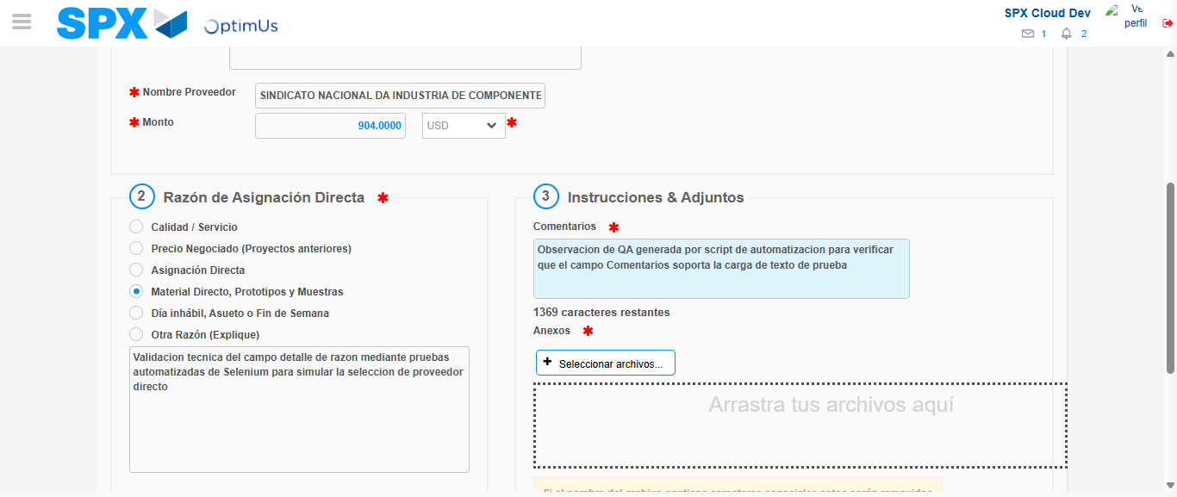Image file-name: QC_Testing-tc002_SPX_Dev5_Crear_Requisicion_Spot_Con_FAD_Tipo_Cobro_CC-1790179013672

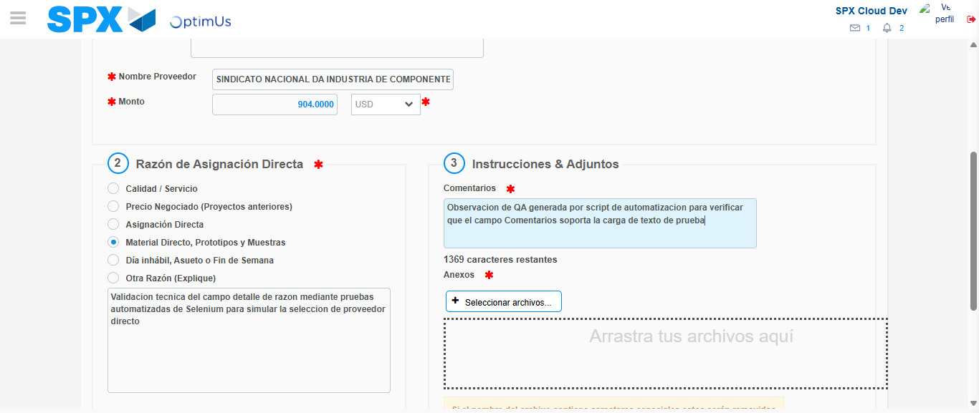Image file-name: QC_Testing-tc002_SPX_Dev5_Crear_Requisicion_Spot_Con_FAD_Tipo_Cobro_CC-1790179014185

Step 4 - Data Capture Spot Buy Requisition: Data captured correctly
Image file-name: QC_Testing-tc002_SPX_Dev5_Crear_Requisicion_Spot_Con_FAD_Tipo_Cobro_CC-1790178989720

Image file-name: QC_Testing-tc002_SPX_Dev5_Crear_Requisicion_Spot_Con_FAD_Tipo_Cobro_CC-1790178989957

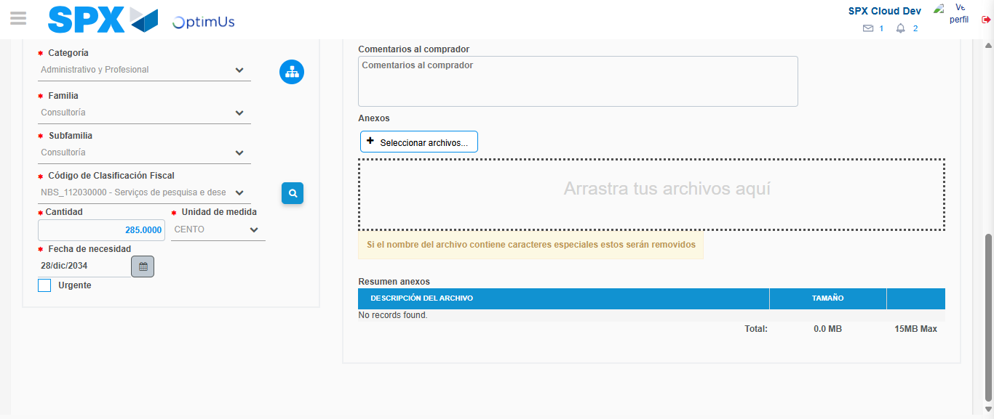Image file-name: QC_Testing-tc002_SPX_Dev5_Crear_Requisicion_Spot_Con_FAD_Tipo_Cobro_CC-1790179031501

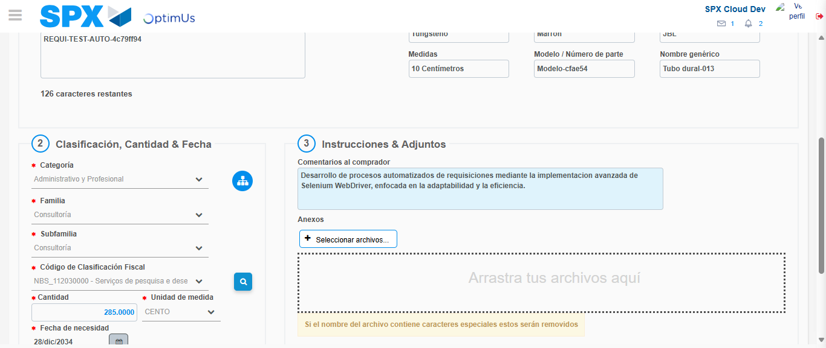Image file-name: QC_Testing-tc002_SPX_Dev5_Crear_Requisicion_Spot_Con_FAD_Tipo_Cobro_CC-1790179042233

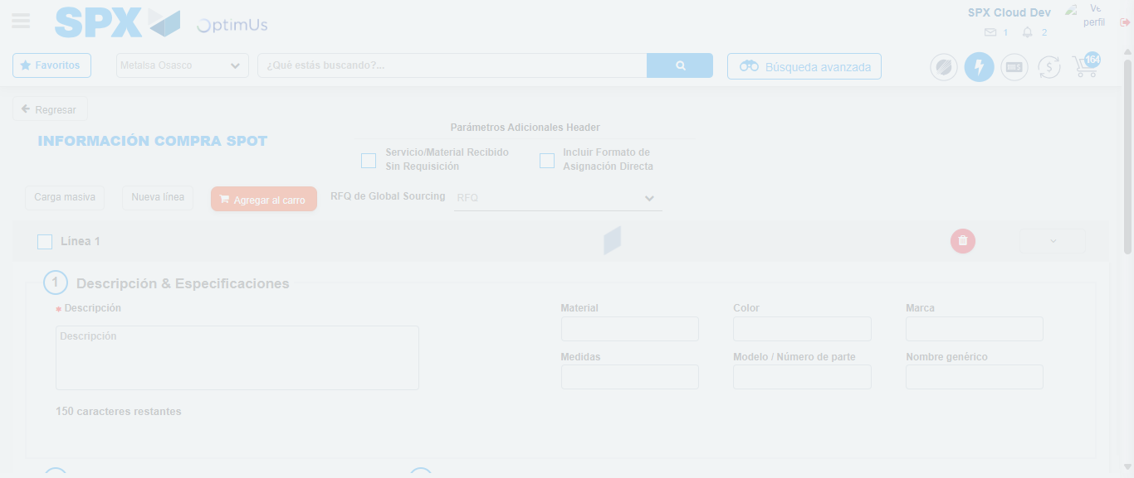Image file-name: QC_Testing-tc002_SPX_Dev5_Crear_Requisicion_Spot_Con_FAD_Tipo_Cobro_CC-1790179053391

Step 8 - Return to Main Page SPX : Return to Main Page SPX
Image file-name: QC_Testing-tc002_SPX_Dev5_Crear_Requisicion_Spot_Con_FAD_Tipo_Cobro_CC-1790178984890

Image file-name: QC_Testing-tc002_SPX_Dev5_Crear_Requisicion_Spot_Con_FAD_Tipo_Cobro_CC-1790178985375

Image file-name: QC_Testing-tc002_SPX_Dev5_Crear_Requisicion_Spot_Con_FAD_Tipo_Cobro_CC-1790178989461

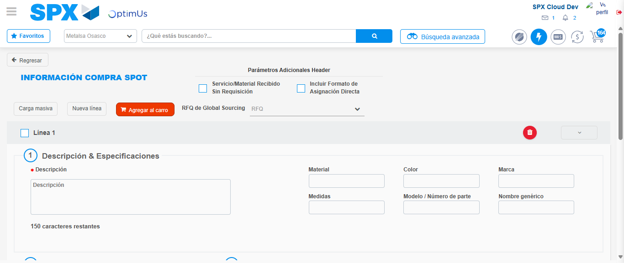Image file-name: QC_Testing-tc002_SPX_Dev5_Crear_Requisicion_Spot_Con_FAD_Tipo_Cobro_CC-1790179055611

Image file-name: QC_Testing-tc002_SPX_Dev5_Crear_Requisicion_Spot_Con_FAD_Tipo_Cobro_CC-1790179055778

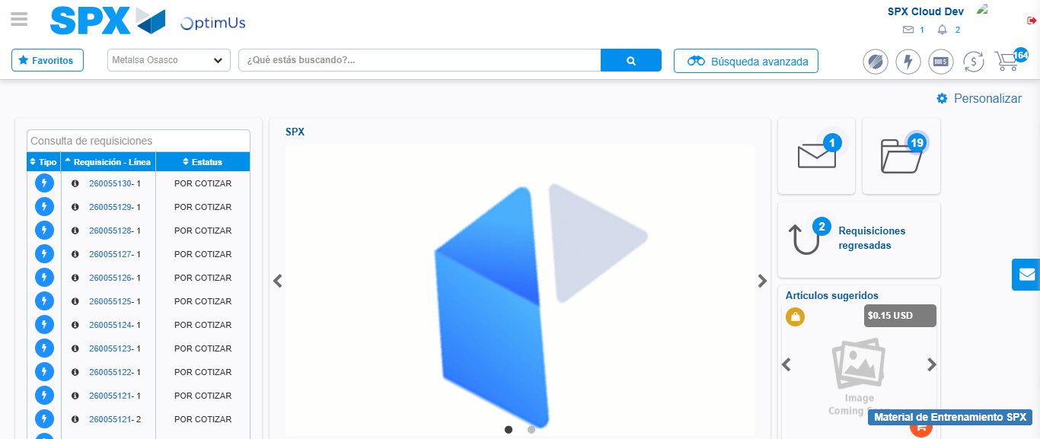Image file-name: QC_Testing-tc002_SPX_Dev5_Crear_Requisicion_Spot_Con_FAD_Tipo_Cobro_CC-1790179076799

Step 9 - Log Out : Log Out SPX
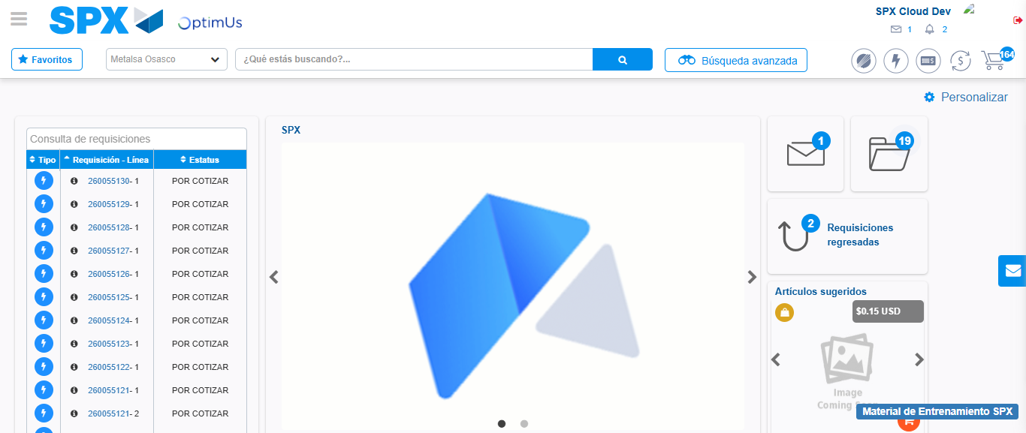Image file-name: QC_Testing-tc002_SPX_Dev5_Crear_Requisicion_Spot_Con_FAD_Tipo_Cobro_CC-1790179077068

